Subject Code | : | CEUE203 | Semester | : | 3 | Academic Year | : | 2026-27
Subject Name | : | Object-Oriented Programming

 | Practical 1
Program: 1.1 | 1. Vending machine (VendingMachine.java, main in this file) (a) Define an enum Coin with constants ONE, TWO, FIVE, TEN. (b) In main, set a snack price of 15 and a running total of 0; create a Scanner. (c) Loop: read a coin name, use a switch expression to convert the Coin to its value (ONE→1, TWO→2, FIVE→5, TEN→10), add it to the total, and print the total so far. (d) Stop the loop once the total reaches 15 or more. (e) Print the change to return (total − 15). Expected output: TEN then FIVE prints “Paid. Change: 0”; TEN then TEN prints “Paid. Change: 5”
Code | import java.util.Scanner;  enum Coin  {  ONE,TWO,FIVE,TEN  };  public class VendingMachine {  public static void main(String[] args)  {  int snack_price=15;  int total=0;  Scanner sc=new Scanner(System.in);  while(total<snack_price)  {  System.out.println("enter coin : ");  String coin=sc.next();  Coin coin_in = Coin.valueOf(coin);  int value=switch(coin_in)  {  case ONE -> 1;  case TWO -> 2;  case FIVE -> 5;  case TEN -> 10;  default -> 0;  };  total+=value;  System.out.println(" current total :" + total);  }  int rem=total-snack_price;  System.out.println("paid."+"change : "+rem);  sc.close();  }  }

Output | 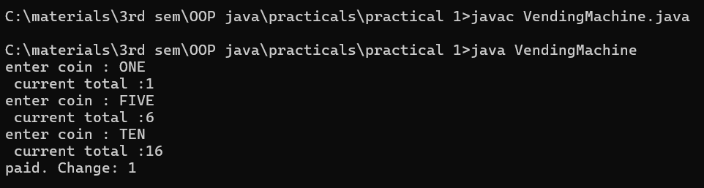
Program: 1.2 | Toll booth (TollBooth.java, main in this file) (a) Define a record Vehicle(String number, String type). (b) In main, keep a running toll total and three counters (bike, car, truck). (c) Loop until the user types “done” for the number: build a Vehicle, use a switch expression on its type for the toll (bike→20, car→50, truck→150), add to the total, and increment that type’s counter. (d) After the loop, print the total toll and the type with the highest count. Expected output: two cars + one bike → “Total toll: 120”, “Most frequent: car”.
Code: | import java.util.Scanner;  record Vehicle(String number,String type)  {  }  public class TollBooth {  public static void main(String[] args)  {  int total=0;  int car=0,bike=0,truck=0;  Scanner sc =new Scanner(System.in);  while(true)  {  System.out.print("Enter vehicle number : ");  String num= sc.next();  if(num.equals("done"))  {  break;  }  System.out.print("Enter vehicle type : ");  String typ= sc.next();  Vehicle v= new Vehicle(num,typ);  int value=switch(v.type())  {  case "bike" ->  {  bike++;  yield 20;  }  case "car" ->  {  car++;  yield 50;  }  case "truck"->  {  truck++;  yield 150;  }  default ->  {  System.out.println("invalid vehicle type");  yield 0;  }  };  total+=value;  }  System.out.println("total toll : "+ total);  String most;  if(car>=bike && car>=truck)  {  most="car";  }  else if(bike>=car && bike>=truck)  {  most="bike";  }  else  {  most="truck";  }  System.out.println("most frequently : "+ most);  sc.close();  }  }
Output: | 